Dear :
It has been my pleasure to provide your orthopaedic surgical care. The following instructions are meant to answer any questions that I may not have addressed at the time of surgery. Please read over the instructions and feel free to contact me if you have any questions or concerns pertaining to your care.

Wound care
- The surgical incisions will be hidden beneath the bandages. Change the dressings on . After changing the dressings, you may shower but do not soak the incisions. You may cover the incisions with gauze and then re-wrap with the Ace wrap.
Activity
- You may put weight on the leg as tolerated. To help control swelling, it is recommended that you keep the extremity elevated above the heart level and to wear the Ace wrap. I also recommend that you ice the knee down for at least 20 minutes three times a day. I have included a “Knee Arthroscopy Exercise Guide” with these instructions. It is advised that you start with the “Initial Exercise Program” and gradually work your way up to the “Advanced Exercise Program” at your discretion.
- Driving: It is recommended that you do not drive until you are no longer taking narcotic pain medications.
Medications
- A prescription for pain medication ( /acetaminophen) has been provided. You may take 1 or 2 of these tablets every 4-6 hours as needed. The pain medication may cause constipation. If constipation becomes a problem, a stool softener such as Colace may be obtained over the counter.
Follow-up Appointment
- Your next appointment is scheduled for . If this appointment time is not convenient, please feel free to contact the office to change the appointment time/date. Please bring the photos from your surgery with you at this appointment so that I can review them with you.
Contact information
- If there are any questions pertaining to your care, please feel free to contact my office. If calling the New Orleans office, please ask for my nurse Andrea. If you are calling the Kenner office, please ask for my nurse Tammie.
- If you have any difficulty reaching me, please contact me on my private answering service line at 504-777-3656. I will do my best to call you back in a timely manner.

Thank you for trusting me as your surgeon. I look forward to seeing you in the near future.

Sincerely,
Michael W. Hartman, MD, FAAOS

Knee Arthroscopy Exercise Guide

Importance of Exercise
Regular exercise to restore your knee mobility and strength is necessary. For the most part, this can be carried out at home.
I recommend that you exercise approximately 20 to 30 minutes two or three times a day.
Before You Start
As you increase the intensity of your exercise program, you may experience temporary set backs. If your knee swells or hurts after a particular exercise activity, you should lessen or stop the activity until you feel better.
You should Rest, Ice, Compress (with an elastic bandage), and Elevate your knee (R.I.C.E.).
Initial Exercise Program
Hamstring Contraction
Repeat 10 times.
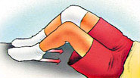
No movement should occur in this exercise. Lie or sit with your knees bent to about 10 degrees. Pull your heel into the floor, tightening the muscles on the back of your thigh. Hold 5 seconds, then relax

Quadriceps Contraction
Repeat 10 times.
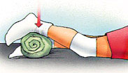
Lie on stomach with a towel roll under the ankle of your operated knee. Push ankle down into the towel roll. Your leg should straighten as much as possible. Hold for 5 seconds. Relax.

Straight Leg Raises
Repeat 10 times.
Lie on your back, with uninvolved knee bent, straighten your involved knee. Slowly lift about 6 inches and hold for 5 seconds. Continue lifting in 6-inch increments, hold each time. Reverse the procedure, and return to the starting position.
Advanced: Before starting, add weights to your ankle, starting with 1 pound of weight and building up to a maximum of 5 pounds of weight over 4 weeks.

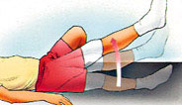
Buttock Tucks
Repeat 10 times.
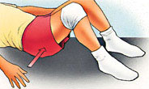
While lying down on your back, tighten your buttock muscles. Hold tightly for 5 seconds.

Straight Leg Raises, Standing
Repeat 10 times.
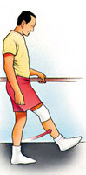
Support yourself, if necessary, and slowly lift your leg forward keeping your knee straight. Return to the starting position.
Advanced: Before starting, add weights to your ankle, starting with 1 pound of weight and building up to a maximum of 5 pounds of weight over 4 weeks

Intermediate Exercise Program
Terminal Knee Extension, Supine
Repeat 10 times.
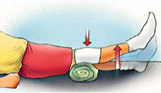
Lie on your back with a towel roll under your knee. Straighten your knee (still supported by the roll) and hold 5 seconds. Slowly return to the starting position.
Advanced: Before starting, add weights to your ankle, starting with 1 pound of weight and building up to a maximum of 5 pounds of weight over 4 weeks.

Straight Leg Raises
Perform 5 sets of 10 repetitions.
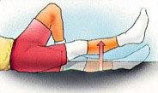
Lie on your back, with your uninvolved knee bent. Straighten your other knee with a quadriceps muscle contraction. Now, slowly raise your leg until your foot is about 12 inches from the floor. Slowly lower it to the floor and relax.
Advanced: Before starting, add weights to your ankle, starting with 1 pound of weight and building up to a maximum of 5 pounds of weight over 4 weeks.

Partial Squat, with Chair
Repeat 10 times.
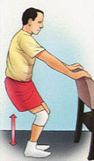
Hold onto a sturdy chair or counter with your feet 6-12 inches from the chair or counter. Do not bend all the way down. DO NOT go any lower than 90 degrees. Keep back straight. Hold for 5-10 seconds. Slowly come back up. Relax.

Quadriceps Stretch, Standing
Repeat 10 times.
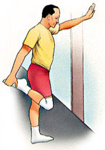
Standing with the involved knee bent, gently pull heel toward buttocks, feeling a stretch in the front of the leg. Hold for 5 seconds.

Advanced Exercise Program
Knee Bend, Partial, Single Leg
Repeat 10 times.
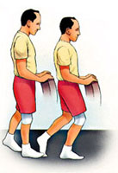
Stand supporting yourself with the back of a chair. Bend your uninvolved leg with your toe touching for balance as necessary. Slowly lower yourself, keeping your foot flat. Do not overdo this exercise. Straighten up to the starting position. Relax.

Step-ups, Forward
Repeat 10 times.
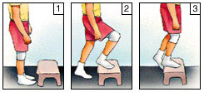
Step forward up onto a 6-inch high stool, leading with your involved leg. Step down, returning to the starting position. Increase the height of the platform as strength increases.

Step-ups, Lateral
Repeat 10 times.
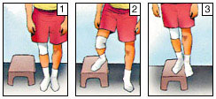
Step up onto a 6-inch high stool, leading with your involved leg. Step down, returning to the starting position. Increase the height of the platform as strength increases.

Terminal Knee Extension, Sitting
Repeat 10 times.
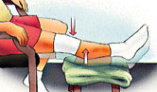
While sitting in a chair, support your involved heel on a stool. Now straighten your knee, hold 5 seconds, and slowly return to the starting position.

Hamstring Stretch, Supine
Repeat 10 times.
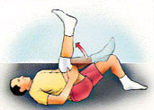
Lie on your back. Bend your hip, grasping your thigh just above the knee. Slowly straighten your knee until you feel the tightness behind your knee. Hold for 5 seconds. Relax.
Repeat with the other leg.
If you do not feel this stretch, bend your hip a little more, and repeat.
No bouncing! Maintain a steady, prolonged stretch for the maximum benefit.

Hamstring Stretch, Supine at Wall
Repeat 10 times.
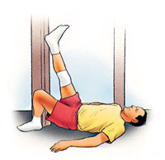
Lie next to a doorway with one leg extended. Place your heel against the wall. The closer you are to the wall, the more intense the stretch. With your knee bent, move your hips toward the wall. Now begin to straighten your knee. When you feel the tightness behind your knee, hold for 5 seconds. Relax.

Repeat with the other leg.
Exercise Bike
Start pedaling for 10 minutes a day.
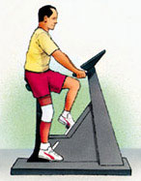
If you have access to an exercise bike, set the seat high so your foot can barely reach the pedal and complete a full revolution. Set the resistance to "light" and progress to "heavy."
Increase the duration by one minute a day until you are pedaling 20 minutes a day.

Walking
An excellent physical exercise activity in the middle stages of your recovery from surgery (after 2 weeks).
Running
Running should be avoided until 6 to 8 weeks because of the impact and shock forces transmitted to your knee. Both walking and running activities should be gradually phased into your exercise program.

